Q-1:
Represent the following English sentences using a semantic network:
"Frosty is a snowman. A snowman is made of snow. Snow is frozen water. It is slippery and soft. Snow is cold. Ice is also cold. It is also frozen water, but unlike snow, which is soft, ice is hard. Ice is clear in color."

Water
soft
slippery
white
snow
snowman
cold
frosty
ice
hard
clear
form of
made of
instance of
color
hardness
texture
temperature
temperature
color
hardness
form of
texture
Fig. Semantic network

Q-2:
Represent the following English sentences using a semantic network:
Tom is a cat. Tom caught a bird. Tom is owned by John. Tom is ginger in colour. Cats like cream. The cat sat on the mat. A cat is a mammal. A bird is an animal. All mammals are animals. Mammals have fur.
Fur
Animal
Cat
Bird
Mammal
Mat
John
Cream
Tom
Ginger
has
sat_on
like
is_a
caught
is_coloured
is_owned_by
Fig. Semantic network
is_a
is_a
is_a

Prolog representation:
cat(tom).
cat(cat1).
mat(mat1).
sat_on(cat1, mat1).
bird(bird1).
caught(tom, bird1).
like(X, cream) :– cat(X).
mammal(X) :– cat(X).
has(X, fur) :– mammal(X).
animal(X) :– mammal(X).
animal(X) :– bird(X).
owns(john, tom).
is_coloured(tom, ginger).

Q-3:
Following are some statements which we need to represent in the form of nodes and arcs.
Statements:
Jerry is a cat.
Jerry is a mammal
Jerry is owned by Priya.
Jerry is brown colored.
All Mammals are animal.
Fig. Semantic network
Mammal
Animal
Cat
Brown
Jerry
is_a
is_a
is_a
Priya
is-owned
is-colored

Q-4:
Represent the following English sentences using a semantic network:
A trout is a fish. A fish has gills. A fish has fins. Fish is food. Fish is animal. An apple is a fruit. Fruit has a stem. Fruit is food. Fruit is vegetable. An animal is a living thing. A vegetable is a living thing.

Fig. Semantic network
stem
fruit
living_thing
fins
food
apple
vegetable
trout
animal
gills
is
fish
is_a
is_a
is
is
has_a
has
has
has
is
is_a
is_a

Q-5:
Represent the following English sentences using a semantic network:
- A tiger is a cat.
- A tiger has stripes.
- A tiger is wild.
- A tabbie is a cat.
- A tabbie has stripes.
- A tabbie is a pet.
- A flag has stripes.
- A flag is an artifact.
- A cat is a mammal.
- A mammal is an animal.
- A dog is a mammal.
- A dog is a pet.
- A dog barks.

Q-6:
Construct semantic network based on the following scenario. Use round for an object and line for the relationship.
Kasem is 45 year-old man who has 2 wives and 7 kids. He works as a surgeon in a private hospital and owns a Naza Ria. Naza Ria is distributed by the Naza Motors. This car has a capacity of 7 seats, black in colour and 2.5 cylinder. Naza Motors also distributes Brabus, Peugeot, Ferrari, Maserati, Chevrolet, Citroen and few more.

Q-7:
Construct semantic network for the following English sentences:
Tom is an instance of dog.
Tom caught a cat.
Tom is owned by Rashan.
Tom is brown in colour.
Dogs like bones.
The dog sat on the mat.
A dog is a mammal.
A cat is an instance of animal.
All mammals are animals.
Mammals have fur.

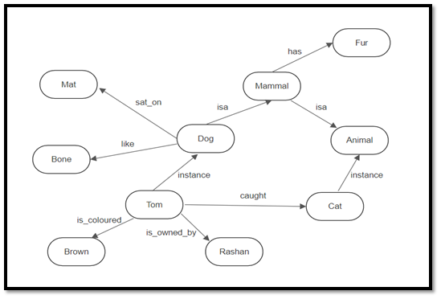

Q-8:
Illustrate the following semantic network:
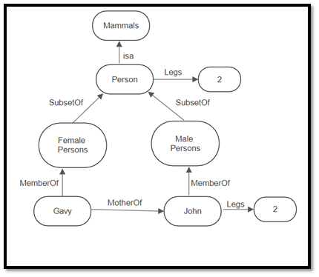

Q-9:
Represent the following sentences into a semantic network:
- Marcus was a man
- Marcus was a Pompeian
- All Pompeians were Romans
- Caesar was a ruler
- Marcus tried to assassinate Caesar
- All men are persons
- Height of Marcus was 72.

Roman
isa
person
Marcus
ruler
Pompeian
man
72
Caesar
isa
instanc-of
instanc-of
instanc-of
height
try-assasinate

Q-10:
Represent the following sentences into a semantic network:
- Birds are animals.
- Birds have feathers, fly and lay eggs.
- Albatros is a bird.
- Donald is a bird.
- Tracy is an albatros.

bird
isa
yes
feathers
albatros
eggs
Donald
animal
Tracy
instanc-of
isa
has
lay
isa
fly

Q-11:
Following are some statements which we need to represent in the form of nodes and arcs.
Statements:
Jerry is a cat.
Jerry is a mammal.
Jerry is owned by Jay.
Jerry is white colored.
All Mammals are animal.
Jerry likes cheese.
Mammal
Animal
Cat
white
Jerry
is_a
is_a
is_a
Jay
is-owned
is-colored
cheese
like

